Great Books to consider buying your child
- Maus by Art Spiegelman- Art Spiegelman interviews his father about his experiences as a Holocaust Survivor. Symbolism is used to depict Jews as mice and Germans as cats.
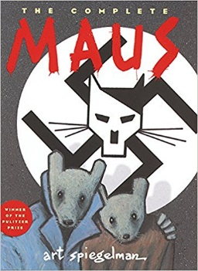

- Jerusalem: Chronicles from the Holy City by Guy Delisle- A chronicle of Delisle’s trip to Jerusalem where he often encountered aspects of the Israeli- Palestinian conflict.
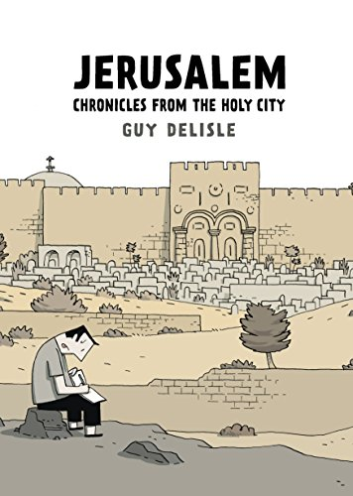

- Palestine by Joe Sacco- A graphic novel about Sacco’s experiences in the West Bank/ Gaza Strip in Dec. 91’ & Jan. 92’. (Empathetic to the Palestinian cause)
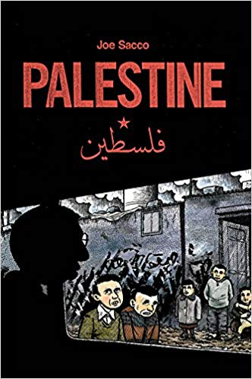
- Persepolis by Marjane Satrapi- A graphic autobiography of Marjane Satrapi that depicts her childhood up to her early adult years in Iran during and after the Islamic Revolution.
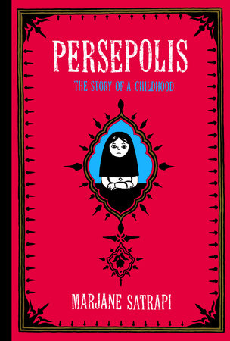

- Diary of Anne Frank- Iconic diary of Anne Frank that details her years in hiding

Essays you can find online for free
- Civil Disobedience by Henry David Thoreau- An essay that states that governments have a duty against injustice

- Letters from a Birmingham Jail by MLK- Open letter by MLK Jr. detailing his strategies and reasons for nonviolence protest

